**DAILY ONLINE ACTIVITIES SUMMARY**

|  |  |  |  |  |  |  |  |  |
| --- | --- | --- | --- | --- | --- | --- | --- | --- |
| **Date:** | **21-07-2020** | | | | | **Name:** | **Anix Jugal D’Cunha** | |
| **Sem & Sec** | **8 sem , A sec** | | | | | **USN:** | **4AL16CS013** | |
| **Online Test Summary** | | | | | | | | |
| **Subject** | | **Not Conducted** | | | | | | |
| **Max. Marks** | | **--** | | **Score** | | | **--** | |
| **Certification Course Summary** | | | | | | | | |
| **Course** | Beginner PHP and MySQL Tutorial | | | | | | | |
| **Certificate Provider** | | | **Udemy** | | **Duration** | | | 10hr 42min |
| **Coding Challenges** | | | | | | | | |
| **Problem Statement:** Fahrenheit to Celsius Using method. | | | | | | | | |
| **Status: Competed** | | | | | | | | |
| **Uploaded the report in Github** | | | | | **yes** | | | |
| **If yes Repository name** | | | | | **alvas-education-foundation/dcunhaanixjugal** | | | |
| **Uploaded the report in slack** | | | | | **yes** | | | |

Online Test Details: (Attach the snapshot and briefly write the report for the same)

**Not Conducted**

Certification Course Details: (Attach the snapshot and briefly write the report for the same)

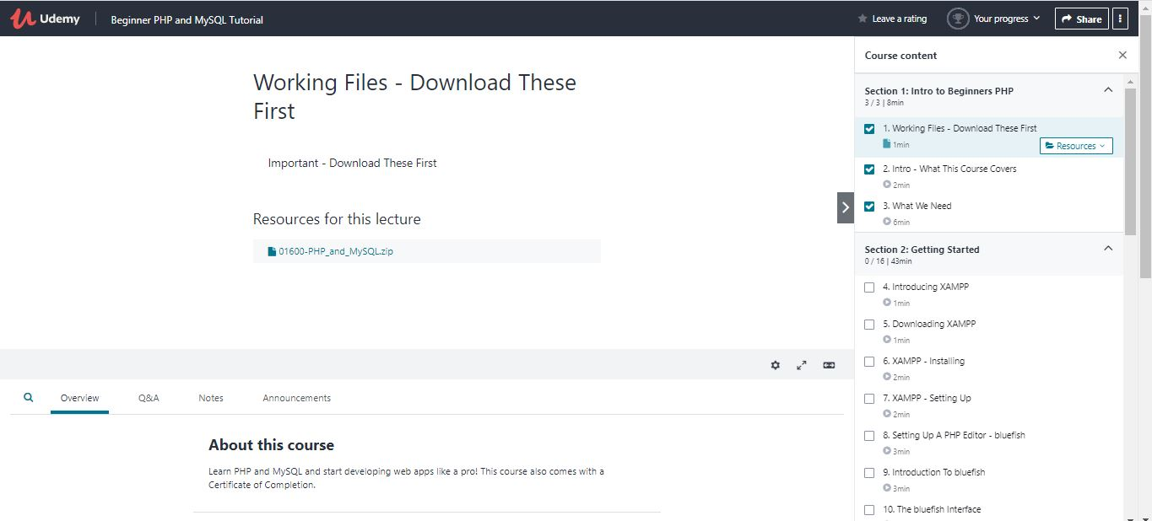

Coding Challenges Details: (Attach the snapshot and briefly write the report for the same)

## Program-> Fahrenheit to Celsius Using method.

|  |
| --- |
|  |

**import java.util.Scanner;**

**class FahrenheittoCelsius**

**{**

**public static void main(String arg[])**

**{**

**double a,c;**

**Scanner sc=new Scanner(System.in);**

**System.out.println("Enter Fahrenheit temperature");**

**a=sc.nextDouble();**

**System.out.println("Celsius temperature is = "+celsius(a));**

**}**

**static double celsius(double f)**

**{**

**return (f-32)*5/9;**

**}**

**}**

**output:**

**Enter Fahrenheit temperature**

**56**

**Celsius temperature is = 13.333333333333334**